Feminism

Reading
- Fisher, M., & Smart, M. “Chapter 7: Sleeping with the enemy: Feminism,” in Smart, S. (Ed.). (2016). A spectator’s guide to worldviews: Ten ways of understanding life. 3rd ed. Blue Bottle.

Definitions
- “Feminism, the belief in social, economic, and political equality of the sexes” www.britannica.com/topic/feminism
- “gender egalitarianism, sex equality, or sexual equality, condition of parity regardless of an individual’s gender” https://www.britannica.com/topic/gender-equality

More Terms
- “ruled or controlled by men” https://dictionary.cambridge.org/dictionary/english/patriarchal
- “ruled or controlled by women or females” https://dictionary.cambridge.org/dictionary/english/matriarchal
- “suggesting that the members of one sex are less able, intelligent, etc. than the members of the other sex, or referring to that sex's bodies, behaviour, or feelings in a negative way” https://dictionary.cambridge.org/dictionary/english/sexist

Feminist Waves (simplified)
- First (1800’s–1920’s): the right to vote
- Second (1960’s–70’s): issues around the sexual revolution and pregnancy (the pill, abortion, and the connection between womanhood and motherhood).
- Third (mid 1990’s): more emphasis on women of color. Raunch culture. Intersectionality.
- Fourth (2012’s–): MeToo movement. Social media. Trans rights.
- “feminism is part of a larger consciousness of oppression along with racism, ageism, classism, abelism, and sexual orientation” (Martha Rampton. “Four Waves of Feminism.” Pacific magazine 2008. https://www.pacificu.edu/magazine/four-waves-feminism).

The Bible and Women
- Gen 1:27 “God created humankind in his own image, in the image of God he created them, male and female he created them” (NET).
- Gen 3:16 “To the woman he said, “I will greatly increase your labor pains; with pain you will give birth to children. You will want to control your husband, but he will dominate you.” (NET)

Colossians 3:18–19 NET
- Wives, submit yourselves to your husbands, as is fitting in the Lord.
- Husbands, love your wives and do not be harsh with them.

Jesus and women
- Luke 8:1–3; 10:38–42; John 4; Mark 7:24-30; Matthew 15:21-28; Mark 16; Luke 24; Matt 28; John 20…

1 Tim 2:11–15 NET2
- 11 A woman must learn quietly with all submissiveness. 12 But I do not allow a woman to teach or exercise authority over a man. She must remain quiet. 13 For Adam was formed first and then Eve. 14 And Adam was not deceived, but the woman, because she was fully deceived, fell into transgression. 15 But she will be delivered through childbearing, if she continues in faith and love and holiness with self-control.

1Cor 14:33–35 NET2
- As in all the churches of the saints, 34 the women should be silent in the churches, for they are not permitted to speak. Rather, let them be in submission, as in fact the law says. 35 If they want to find out about something, they should ask their husbands at home, because it is disgraceful for a woman to speak in church.

Conclusion?
- What is the Christian view of women?
- Beck, James R., ed. Two Views on Women in Ministry. Grand Rapids, MI: Zondervan, 2005.

Discussion from chapter 7 on Feminism
- When does the concept of choice—choice in career, in family, in terms of reproduction—have its limits? At what point does responsibility play a part in rightly limiting our choices?
- In the struggle for women’s rights, what role is there in emphasizing the similarity between men and women? When can a focus on the differences between the genders contribute to the same discussion?
- To what degree do you think Christianity has contributed to the well-being of females in the Western world?
- What is the significance of Jesus’ attitude to women in an assessment of the links between feminism and Christianity?

How do other Worldviews see the place of Women?
- Naturalism
- Islam
- Hinduism
- Buddhism
- Others

In what ways do you think women are still not treated equally?

Video
- Christian Hoff Sommers. World Cup pay gap: Here's why it's justified | FACTUAL FEMINIST. Jul 28, 2015. https://youtu.be/KfDynQFUHys 5:02mins

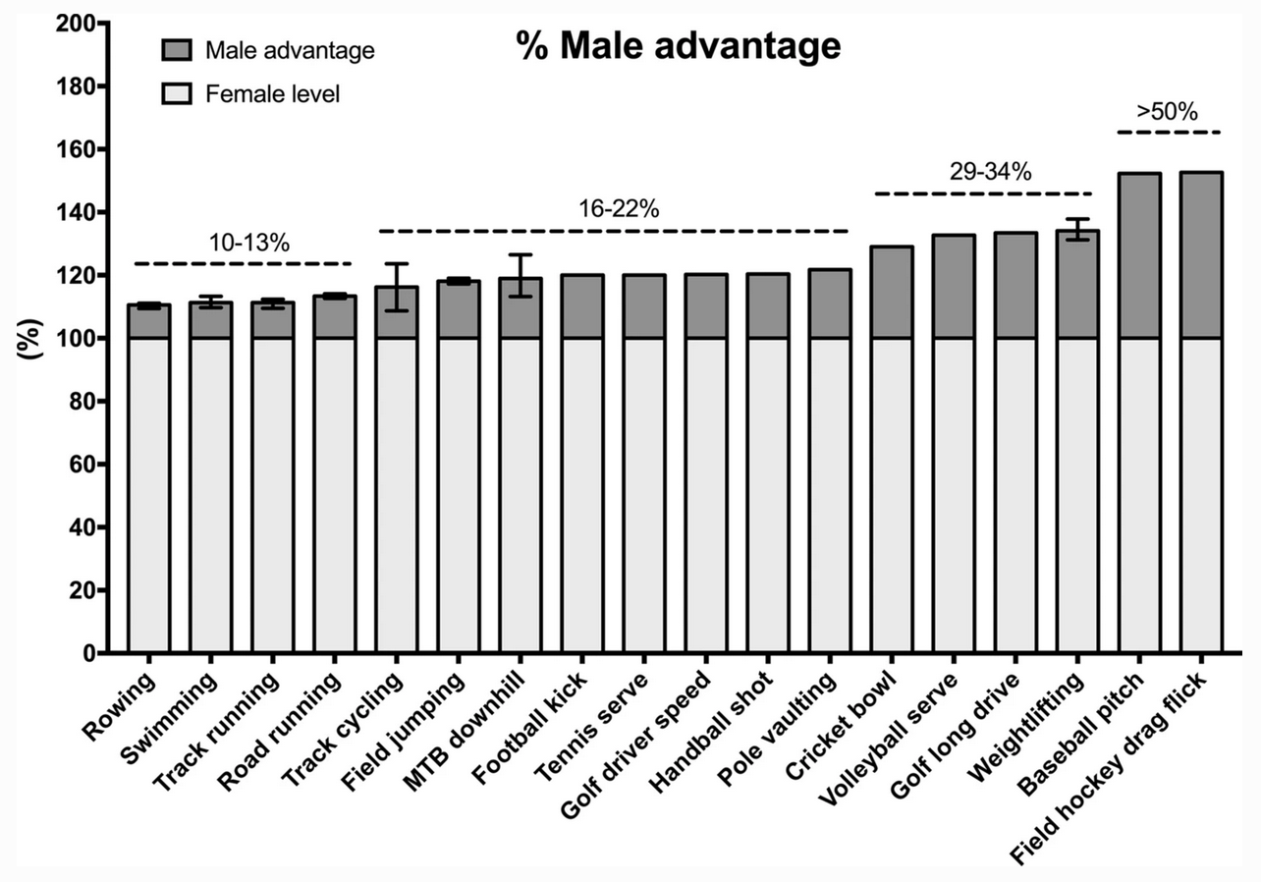

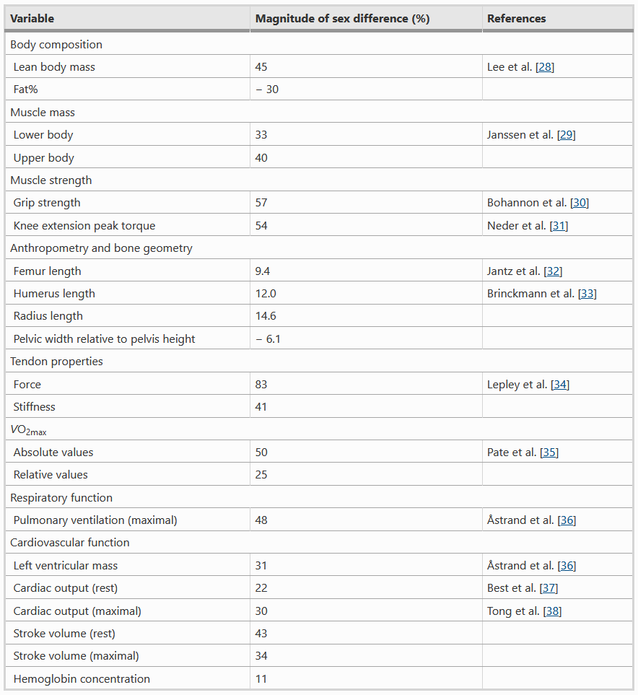
Hilton, E.N., Lundberg, T.R. Transgender Women in the Female Category of Sport: Perspectives on Testosterone Suppression and Performance Advantage. Sports Med 51 (2021): 199–214. https://doi.org/10.1007/s40279-020-01389-3

Defining Sex and Gender
- “Gender refers to the characteristics of women, men, girls and boys that are socially constructed” https://www.who.int/health-topics/gender
- “sex, which refers to the different biological and physiological characteristics of females, males and intersex persons, such as chromosomes, hormones and reproductive organs” https://www.who.int/health-topics/gender

More Terms
- “Definition of cisgender: of, relating to, or being a person whose gender identity corresponds with the sex the person had or was identified as having at birth” https://www.merriam-webster.com/dictionary/cisgender
- “Definition of transgender: of, relating to, or being a person whose gender identity differs from the sex the person had or was identified as having at birth” https://www.merriam-webster.com/dictionary/transgender
- “Definition of intersexuality: : the condition (such as that occurring in congenital adrenal hyperplasia or androgen insensitivity syndrome) of either having both male and female gonadal tissue in one individual or of having the gonads of one sex and external genitalia that is of the other sex or is ambiguous” https://www.merriam-webster.com/dictionary/intersexuality

Bogardus, “Evaluating Arguments for the Sex/Gender Distinction.”
- “Many philosophers believe that our ordinary English words man and woman are “gender terms,” and gender is distinct from biological sex. That is, they believe womanhood and manhood are not defined even partly by biological sex. This sex/gender distinction is one of the most influential ideas of the twentieth century on the broader culture, both popular and academic. Less well known are the reasons to think it’s true. My interest in this paper is to show that, upon investigation, the arguments for the sex/gender distinction have feet of clay. In fact, they all fail. We will survey the literature and tour arguments in favor of the sex/gender distinction, and then we’ll critically evaluate those arguments. We’ll consider the argument from resisting biological determinism, the argument from biologically intersex people and vagueness, the argument from the normativity of gender, and some arguments from thought experiments. We’ll see that these arguments are not up to the task of supporting the sex/ gender distinction; they simply don’t work. So, philosophers should either develop stronger arguments for the sex/gender distinction, or cultivate a variety of feminism that’s consistent with the traditional, biologically-based definitions of woman and man.”

Men’s Rights?
- Male Suicides 4 times that of Females
- Family Courts Causing Men to commit Suicide
- Family Law and shared parenting as a RIGHT
- Paternity Deceit / Fraud - Birth Registrations
- Male Domestic Violence Victims
- Men Dying Younger Than Women
https://australianmensrights.com/

Further Resources
Bauckham, Richard. Gospel Women: Studies of the Named Women in the Gospels. Grand Rapids, MI: Eerdmans, 2002.

Beck, James R., ed. Two Views on Women in Ministry. Grand Rapids, MI: Zondervan, rev. 2005.

Belleville, Linda L. Women Leaders and the Church: Three Crucial Questions. Grand Rapids, MI: Baker, 2000.

Bird, Michael F. Bourgeois Babes, Bossy Wives, and Bobby Haircuts: A Case for Gender Equality in Ministry. Grand Rapids, MI: Zondervan, 2011.

Cohick, Lynn H. Women in the World of the Earliest Christians. Grand Rapids, MI: Baker, 2009.

Creegan, Nicola Hoggard and Christine D. Pohl. Living on the Boundaries: Evangelical Women, Feminism and the Theological Academy. Downers Grove, IL: IVP, 2005.

Epp, Eldon J. Junia: The First Woman Apostle. Minneapolis, MN: Fortress, 2005.

Grudem, Wayne A. Evangelical Feminism and Biblical Truth: An Analysis of Over 100 Disputed Questions. Sisters, OR: Multnomah, 2004.

Husbands, Mark and Timothy Larsen, eds. Women, Ministry and the Gospel: Exploring New Paradigms. Downers Grove, IL: IVP, 2007.

Johnson, Alan F. ed. How I Changed My Mind about Women in Leadership. Grand Rapids, MI: Zondervan, 2010.

Kroeger, Catherine Clark and James R. Beck, eds., Women, Abuse, and the Bible: How Scripture Can Be Used to Hurt or Heal. Grand Rapids, MI: Baker, 1996.

Kroeger, Catherine Clark, and Mary J. Evans, eds. The IVP Women’s Bible Commentary. Downers Grove, IL: IVP, 2002.

Lee-Barnewall, Michelle. Neither Complementarian nor Egalitarian. Grand Rapids, MI: Baker, 2016.

McKnight, Scot. Junia is Not Alone. Grand Rapids, MI: Zondervan, 2011.

Osburn, Carroll D., ed. Essays on Women in Earliest Christianity, 2 vols. Joplin, MO: College Press, 1993-95.

Payne, Philip B. Man and Woman, One in Christ. Grand Rapids, MI: Zondervan, 2009.

Peppiatt, Lucy. Unveiling Paul’s Women: Making Sense of 1 Corinthians 11:2-16. Eugene, OR: Cascade, 2018.

Peppiatt, Lucy. Rediscovering Scripture’s Vision for Women. Downers Grove, IL: IVP, 2019.

Pierce, Ronald W. and Rebecca Merrill Groothuis, eds. Discovering Biblical Equality: Complementarity without Hierarchy. Downers Grove, IL: IVP, 2004.

Piper, John and Wayne Grudem, eds. Recovering Biblical Manhood and Womanhood: A Response to Evangelical Feminism. Wheaton: Crossway, 1991.

Reid, Barbara E. Wisdom’s Feast: An Invitation to Feminist Interpretation of the Scriptures. Grand Rapids, MI: Eerdmans, 2016.

Saucy, Robert L. and Judith K. Tenelshof, eds. Women and Men in Ministry: A Complementary Perspective. Chicago: Moody, 2001.

Spencer, F. Scott. Salty Wives, Spirited Mothers, and Savvy Widows: Capable Women of Purpose and Persistence in Luke’s Gospel. Grand Rapids, MI: Eerdmans, 2012.

Sumner, Sarah. Men and Women in the Church: Building Consensus on Christian Leadership. Downers Grove, IL: IVP, 2003.

Tidball, Derek, and Dianne Tidball. The Message of Women. Downers Grove, IL: IVP, 2014.

Van Leeuwen, Mary Stewart. Gender and Grace: Love, Work and Parenting in a Changing World. Downers Grove, IL: IVP, 1990.

Westfall, Cynthia Long. Paul and Gender. Grand Rapids, MI: Baker, 2016.

