Culture
- What is culture and how should we relate to it?

Reading
- Hollinger, D. P. (2002). “Christ and Culture.” In Choosing the Good: Christian Ethics in a Complex World. Grand Rapids, MI: Baker Academic, 189–215.

Definitions of Culture
- Culture is "the more or less integrated system of ideas, feelings, and values and their associated patterns of behavior and products shared by a group of people who organize and regulate what they think, feel, and do.” Paul G. Hiebert, Anthropologic Insights for Missionaries (Grand Rapids, MI: Baker, 1986, 30).

“Culture.” Merriam Webster Dictionary. https://www.merriam-webster.com/dictionary/culture
- a: the customary beliefs, social forms, and material traits of a racial, religious, or social group. also : the characteristic features of everyday existence (such as diversions or a way of life) shared by people in a place or time popular culture.
- b: the set of shared attitudes, values, goals, and practices that characterizes an institution or organization.

“Cultures, Subcultures, and Countercultures: Crash Course Sociology #11” CrashCourse May 22, 2017. https://www.youtube.com/watch?v=RV50AV7-Iwc&feature=youtu.be
- “Mainstream culture: "the cultural patterns that are broadly in line with a society's cultural ideals and values.”
- “Subcultures: cultural patterns that set apart a segment of a society's population.”
- “Ethnocentrism: the practice of judging one culture by the standards of another.”
- “Counter-culture: counter-cultures push back on mainstream culture in an attempt to change how a society functions.”

How we can relate to culture
- Confront (you believe your behavior is the right behaviors)
- Complain
- Conform (adapt to fit)
“How Culture Drives Behaviours | Julien S. Bourrelle | TEDxTrondheim” TEDx Talks Jul 11, 2015. https://www.youtube.com/watch?v=l-Yy6poJ2zs

H. Richard Niebuhr, Christ and Culture, 1951.
- Christ against Culture
- Christ of Culture
- Christ above culture
- Christ and Culture in Paradox
- Christ Transforming Culture

Against Culture
- Definition: culture is evil, so we should reject it.
- Positive: some cultural things are bad and so we should be against that (i.e. if Nazi culture said to mistreat Jews).
- Negative: some elements of culture are not bad, so we do not need to oppose it (i.e. is the culture says to protect the vulnerable.

Of Culture
- Definition: If culture is good, we can embrace it.
- (this is the other end of the spectrum to the “against culture” position, and most people will admit there are both good and bad aspects of culture, so one should not simply be all for or all against, but on a case by case basis decide).

Above Culture
- Definition: Culture is good but needs a touch to make it complete.

Involvement with Culture is a Paradox
- Definition: culture has many bad aspects, but rather then separating oneself from culture, one must engage culture even if that means one will be defiled by it.

Transforming Culture
- Definition: seek to discern how one can transform culture to progress.
- Potential concerns: but by what external standard can we judge a culture and who says others in the culture will want to live according to your values.

Christ and Culture Revisited
- Carson argues that these are not necessarily comprehensive mutually exclusive options, rather depending on the situation one of the approaches would be most appropriate but that does not mean that position is always the way to go.
D. A. Carson. Christ and Culture Revisited. Grand Rapids, MI: Eerdmans, 2008.

Hollinger’s view
- Christ in but not of Culture
- We can simultaneously a worldview within a worldview as well as a countercultural worldview. Thus, Christians in any and every culture should be both within the culture and distinctly different from the culture in genuinely Christian ways.
Hollinger, D. P. (2002). “Christ and Culture.” In Choosing the Good: Christian Ethics in a Complex World. Grand Rapids, MI: Baker Academic, 189–215.

Friesen’s Nine Ways of Engaging Culture
- Opposition
- Agreement
- Neutrality
- Expansion of or going beyond a cultural norm (Like chastity, fasting, and prayer in Islamic societies, for example).
- Creation of alternative institutions (Like hospitals, schools, etc.).
- Revitalization of existing cultural arenas (Like making the current educational system better).
- Revitalization of a cultural practice in light of a higher principle (Like hospitality in Middle Eastern societies).
- Compromise (In non-moral aspects)
- Conversion: individual and structural.
Duane K. Friesen. Artists, Citizens, Philosophers: Seeking the Peace of the City. Scottdale, PA: Herald Press, 2000.

Culturally speaking, what should we eat?
- How much do we need?
- What is physically healthy?
- What is good for the environment?
- What about with regard to concern for the plant or animal?
- What about taste?
- What about cost?
- What about what your culture raised you on?
- Other considerations…

How should we relate to these cultural issues?
- Education
- Energy
- Immigration
- Healthcare
- Age care
- Economics and taxation
- Public infrastructure
- Environment
- Human Rights

Question
- What is one thing you wish you could change about Australian culture?
- Is there one thing you have changed about yourself based on Australian culture?

Role Play: How would you react to these cultural issues?
- Congratulations you got a new job:
- How are you going to get to work?
- When are you going to get to work?
- What will you wear for your first week at work?
- Your contract says you finish work at 5pm, its now 5:00pm so what do you do?

Models of Christian Cultural Influence
- Christian relief: meeting various needs when they arise i.e. bring food when a famine comes, funds to newly employed, rebuilding homes after a storm, etc.
- Christian alternative institutions: creating Christian run facilities to serve the people. i.e. opening a hospital/clinic, or law firm.
- Evangelism: sharing the gospel that those who come to Christ would now live as Christ would have them.
- Prophetic pronouncements: Christian making statements on how things should be. i.e http://manhattandeclaration.org/ on life, marriage and family.
- Lobbying: contacting government and asking them to change policies or organizing a rally to show that the people want change.
- Political parties: Forming a political group to direct attempt to run things.
- Nonviolent resistance: peaceful protesting an issue. i.e. Martin Luther King Jr. and equality.
- Christian embodiment: Living out the message as an example to the world.
- Individual impact: being good Christian citizen wherever God has placed you. i.e. being a Christian carpenter, etc.
Hollinger, D. P. (2002). “Models of Christian Influence.” In Choosing the Good: Christian Ethics in a Complex World. Grand Rapids, MI: Baker Academic, 256–272.

What do you think of these ways to influence culture?
- Prayer: praying for leaders and the country
- Truth: use reason to make a case.
- By example: Live out the message. i.e. model the change you want to see.
- The power of group solidarity: unite as one voice (many under one banner).
John Stott: Four Ways Christians Can Influence the World: How we can be salt and light. October 2011, Vol. 55, No. 10, Pg 38, "Salt & Light" http://www.christianitytoday.com/ct/2011/october/saltlight.html?paging=off

Creating Culture
- Lead the way…

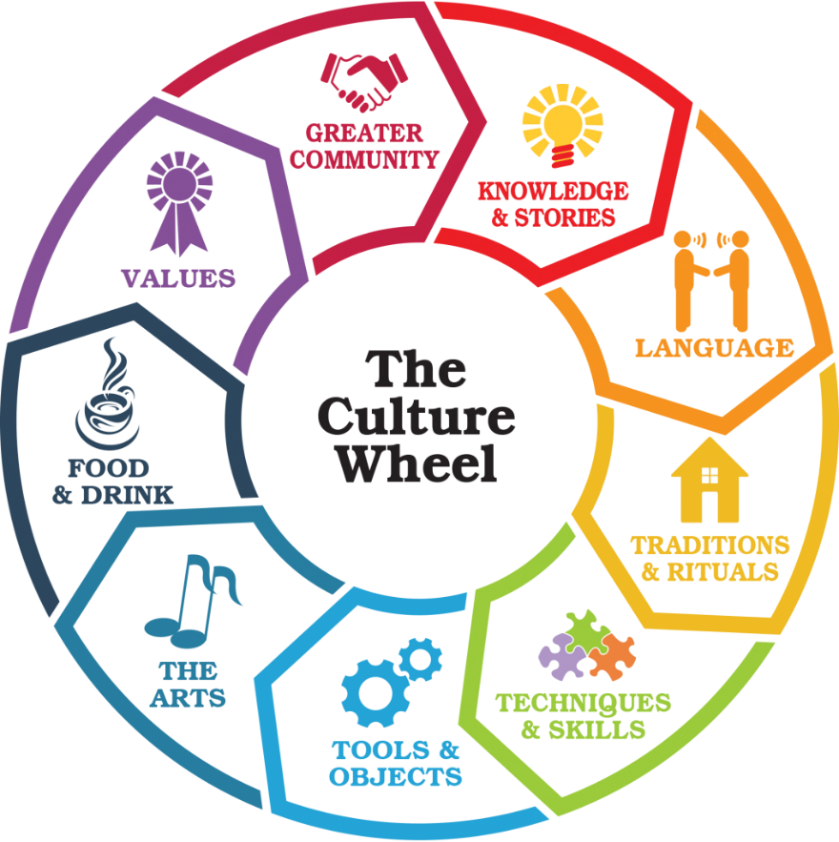
ANDREA. “Celebrating Our Culture: A New How-To-Guide.” Bridges Together. December 21, 2018. https://www.bridgestogether.org/celebrating-our-culture-a-new-how-to-guide/

