The Meaning of Life according to Different Worldviews

What is the Meaning of Life?
- Do any of the worldviews have anything to add to this question?

The meaning of life is to give life meaning.
What is the meaning of life? Whatever you want it to be.

Viktor Frankl
- “For too long we have been dreaming a dream from which we are now waking up: the dream that if we just improve the socioeconomic situation of people, everything will be okay, people will become happy. The truth is that as the struggle for survival has subsided, the question has emerged: survival for what? Ever more people today have the means to live, but no meaning to live for.”

https://en.wikipedia.org/wiki/Meaning_of_life
- To realize one's potential and ideals
- To achieve biological perfection
- To seek wisdom and knowledge
- To do good, to do the right thing
- Meanings relating to religion
- To love, to feel, to enjoy the act of living
- To have power, to be better
- Life has no meaning

Video
- Is life meaningless? And other absurd questions - Nina Medvinskaya. TED-ED. Sep 21, 2020. https://www.youtube.com/watch?v=vPtzpjC7TF4 6:12 mins

David Benatar, The Human Predicament
- “Life is hard. We have to struggle, often unsuccessfully, to keep unpleasantness at bay. It would be easier to make sense of this if life served some important purpose. Yet, while we can create some meaning, our lives lack any ultimate purpose. Death can relieve our suffering, but it cannot solve our problem of meaninglessness. Moreover, because death is annihilation, it is part of our misfortune (even when, all things considered, it is the lesser of two evils). In other words, our predicament is that life is bad but that death is too.” https://blog.oup.com/2017/04/david-benatar-interview/

Dawkins, River out of Eden
- “In a universe of blind physical forces and genetic replication, some people are going to get hurt, other people are going to get lucky, and you won’t find any rhyme or reason in it, nor any justice. The universe we observe has precisely the properties we should expect if there is, at bottom, no design, no purpose, no evil and no good, nothing but blind, pitiless indifference.” Richard Dawkins, River out of Eden (London: Weidenfeld & Nicolson, 1995), 133.

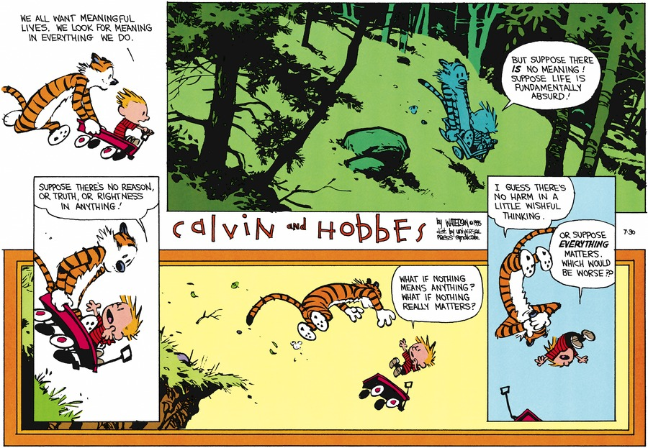
http://www.gocomics.com/calvinandhobbes/1995/07/30
05 JUNE 1994ScriptWe all want meaningful lives. We look for meaning in everything we do. But suppose there IS no meaning! Suppose life is fundamentally absurd! Suppose there's no reason or truth, or rightness in anything! What if nothing means anything? What if nothing really matters? I guess there's no harm in a little wishful thinking. Or suppose EVERYTHING matters. Which would be worse??

What is needed to give life meaning?
- An objective purpose to life
- Everlasting life
- Atheism and Pantheism do not provide a basis for an objective standard, and neither gives much hope for immortality.

The Meaning of Life According to Christianity
- The chief end of humanity is to glorify God and enjoy Him forever.
- That is one and the same thing – meaning God is most glorified in us when we are most satisfied in Him. That is to say that God is most interested in your eternal happiness and God knows that you will have most joy in knowing Him.

What is Happiness? Gould
- “First and most fundamentally, happiness is found in being rightly related to God. This is our highest good and our deepest desire—to know and be known by God. Second, happiness consists of right relations with others and the world around us. This is where justice comes in: we want to treat others well, with justice and love. Third, happiness is found in a right relationship with self. This is the idea of being a certain kind of person, a virtuous person. And finally, happiness is found by being rightly related to our end, our telos, our purpose. We were made to find rest in God; we journey to God and this is where we find our home.” https://worldviewbulletin.substack.com/p/what-is-happiness

Why It Matters?

Pascal’s Wager
 | God exists | God does not exist
Believe | infinite gain | finite loss
Disbelieve | infinite loss | finite gain

